**Leader Overview**

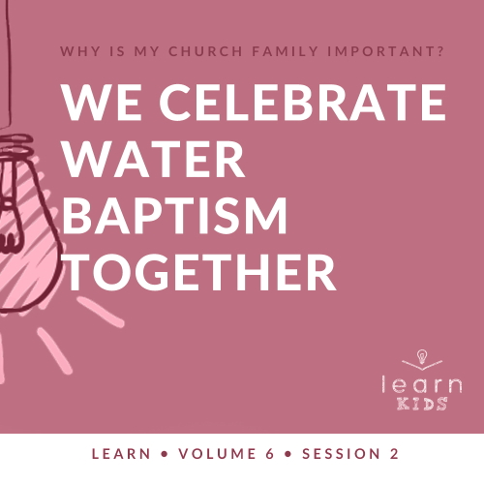

**Volume Overview**

**Why is my church family important?**

*When we think of church, it’s easy for our mind to be instantly drawn to the building where we attend. However, in God’s design, the church isn’t the building that we gather in. Instead, church has everything to do with the people who are gathered there. In essence, the biblical church is not a building that we go to but a family of believers that we belong to*.

*As our Father, God’s heart is to adopt us into His family (*[*Ephesians 1:5*](https://ref.ly/logosref/Bible.Eph1.5)*). When we choose to put our faith in Jesus, we instantly join God’s family. We not only belong to Him, but we also belong to each other. Just like our natural families here on earth were meant to function, God uses our church family to meet our needs. A healthy church family offers love, encouragement, guidance, and accountability. As the family of God—the Church—we grow together, celebrate together, share together, and even serve together. As we make a commitment to God’s family, we will become stronger, more devoted followers of Jesus*.

**Session Overview**

**We Celebrate Water Baptism Together**

*Water baptism has a long history. John the Baptist baptized Jesus in the New Testament, and this discipline continues today. The Church baptizes people in water who have made the decision to follow Jesus. Baptism is a public celebration of our commitment to Christ. It’s a symbol of our unity with Him and His death and resurrection*.

**Bible Lesson**

Lydia and Her Family Are Baptized in Water

[Acts 16:11–15](https://ref.ly/logosref/Bible.Ac16.11-15)

**Faith Fact**

We celebrate together.

**Faith Verse**

[Matthew 18:20](https://ref.ly/logosref/Bible.Mt18.20) (NLT)

“For where two or three gather together as my followers, I am there among them.”

**Preparing for the Session**

**Leader Preparation Time: 20–25 Minutes**

|  |
| --- |
| ***You Will Need***  ***Large Group***   * *Bible* * *Worship songs (Song suggestions: “The Blessing” by Elevation Worship; “The Stand” by Hillsong United; “Broken Vessels” (Amazing Grace) by Hillsong Worship; “This Is a Move” by Bethel Music Worship)* * *For groups not using a phone or tablet only, add:*   *• Projector or TV*  *• Laptop*  *•* ***Faith Fact Slide***  *•* ***Faith Verse Video*** *or* ***Slide***  *•* ***Bible******Lesson Video***  *•* ***Teaching Point Slides 1–3***   * *Birthday party horn* * *Bible* * *Bath toy (duck or other animal)* * *Shallow clear container* * *Water* * *Table*   ***Small Group***   * *Large sponges, two per group* * *Buckets, four per group* * *Water* * *Bibles for kids in your group to share* * ***Small Group Activity Page****, one per kid* * *Crayons or markers*   *To access session content and videos from a computer, visit:* [*BibleEngagementProject.com/downloads*](https://bibleengagementproject.com/downloads) |
| ***Getting Ready***  ***For Session 6.3***   * *Review the Communion options in Session 3 Prayer and Response and choose one. If choosing option 3, you will want to contact parents a couple of days ahead so they can be prepared to be in the session.*   ***For Session 6.4***   * *Order one or more magic towels (small towels that expand in water) for Session 4 Teaching Time. Leader needs one towel. Optional: Buy enough towels to send one home with each kid.*   ***Large Group***  *• Download videos and slides if needed.*  *• Select worship song(s) and have them ready to play.*  *• Read the Bible Lesson Scripture to prepare for Teaching Time.*  *• Fill the shallow container with water.*  ***Small Group***  *• Choose a place to play that can get wet.*  *• Fill two of the buckets for each small group each about 3/4 full of water.*  *• Print copies of the* ***Small Group Activity Page****, one per kid.*  *First time leading* Learn *for Kids? Check out the* [*Facilitator Guide*](https://0b769b0ed3569ef9d18b-f88d8272f61086866d50d048b43ef630.ssl.cf2.rackcdn.com/sites/biblengagementproject/Listen_Facilitator_Guide.pdf)*.* |

**Large Group**

**30 Minutes**

*See what’s needed at the beginning of the session.*

**Introduction**

It’s great to be together again. Today, we’ll answer the big question: Why is my church family important? Last time, we learned that we grow together and need each other. Today, we’ll learn about one thing we can celebrate together as the Church.

Who loves a celebration or party? *(Group response)* Me too! It’s always more fun to celebrate with family and friends than to celebrate alone. One of the things we celebrate together as a church family is when someone makes the decision to follow Jesus and be baptized in water. We’ll learn more about why it’s so important to be baptized and celebrate that decision together.

**Faith Fact**

If you love celebrating, you’ll love today’s Faith Fact: **We celebrate together**.

• *Show the* ***Faith Fact Slide***.

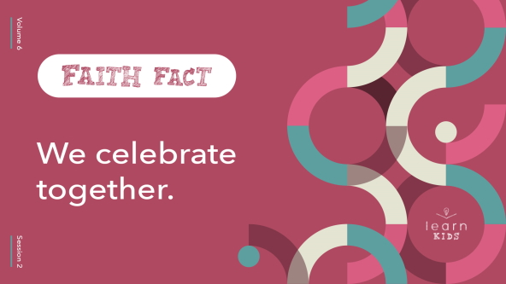

Let’s say the Faith Fact together three more times. After each time, we’re going to have a big celebration. I want to see everyone clapping, cheering, and jumping. Ready? **We celebrate together**.

• *Encourage everyone to celebrate enthusiastically*.

Everything is more fun when we make it a celebration. Let’s say it one more time. **We celebrate together**.

**Game**

**Stand Up If …**

Church isn’t meant to be a place where we only come to sit down and listen to someone tell us how we should live our life. Church is a family of believers. We’re friends who worship together, grow together, and celebrate together. Church should be a place where we can celebrate the “wins” in each other’s life. We’re going to do that in today’s game.

The game is called “Stand Up If.” I’ll say, “Stand up if …” and then follow it with something that’s worth celebrating. You’ll stand up if that statement is true about you. Then, we’ll pause and celebrate everyone who’s standing by clapping and shouting. For each round, if the statement is true about you, stand up, and if it is not true about you, stay in your seat. Let’s go. Stand up if …

• You went somewhere fun on vacation this year.

• You like coming to church.

• You got grades you’re proud of on your last report card.

• You’ve already had a birthday this year.

• You have been baptized in water.

• You play sports, and your team won.

• You won a competition that isn’t sports.

• You’ve got a friend who cares about you.

• You read your Bible last week.

• You prayed about something, and God answered your prayer.

• You did something nice for someone else last week.

• You got a new sibling this year.

• You learned something new this year.

• You are a follower of Jesus.

• You love celebrating together.

I’m so proud of all of you for those amazing accomplishments. Isn’t it fun to be celebrated and to celebrate each other? *(Group response)* Can you think of anything we didn’t celebrate yet that you’d like us to know about? *(Allow responses.)* All this celebration reminds me of our Faith Fact. **We celebrate together**.

**Worship**

It’s even more fun to celebrate God as we worship. Singing and worship can definitely be a celebration. Are you ready to worship God? *(Group response)*

• *Lead the kids in singing one or two praise songs. See suggestions at the beginning of the session*.

**Bible Lesson**

We need to make our worship to God a celebration every single time. We should get more excited about worshipping God than we do about a party or any other event. Why is that? *(Allow responses.)*

When we think about all that God has given to us and what He’s done for us, we should want to celebrate and thank Him. When we read the Bible, it should give us even more reasons to celebrate. Let’s pray and thank Him right now.

**Prayer**

|  |
| --- |
| *Dear God, thank You for giving us so many reasons to celebrate together as a church family. Help us to learn even more about You today. Amen.* |

**Video Intro**

Before we look at the Bible story, let’s watch this video.

• *Play* ***Bible Lesson Video***.

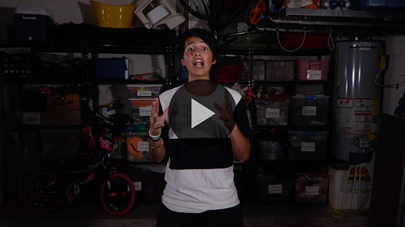

**Bible Story**

**Lydia and Her Family Are Baptized in Water**

That video was such a fun lead-in to our Bible story today. One of the ways the Early Church celebrated together is something we still do today. I’m talking about water baptism. Water baptism services are celebrations. We have a time to celebrate someone choosing to say publicly that they are following Jesus.

Let’s look at one of the Early Church baptisms that’s recorded in the Book of Acts. Grab your Bible or pull up a Bible app on your device. Turn to [Acts 16:11–15](https://ref.ly/logosref/Bible.Ac16.11-15).

• *Read the Bible story aloud to the group*.

• *In order to keep Large Group time moving along, we don’t recommend having the kids read*.

• *Optional: Remind the kids to mark this place with their Bible Bookmark, so they can read it on their own at home*.

**Teaching Time**

|  |
| --- |
| ***You Will Need***   * ***Teaching Slides 1–3*** * *Birthday party horn* * *Bible* * *Bath toy (duck or other animal)* * *Shallow clear container* * *Water* * *Table*   ***Getting Ready***   * *Fill the shallow container with water.* |

Our Bible story talked about a woman named Lydia. One thing that really stands out from the passage we just read is that Lydia already knew about God, but hadn’t yet learned about Jesus. Before Lydia heard Paul’s teaching, the Book of Acts tells us she worshipped God. That worship was probably a lot like what the Jews were doing back then. Since Jesus had come to earth and made a better way for people to be closer to God, Lydia needed to take the next step and follow Him.

After hearing from Paul, God allowed Lydia to understand that Jesus would forgive her sins when she asked. So, Lydia wanted to take the next step and be baptized in water. She didn’t just keep her decision quiet. She was ready to say publicly that she was a follower of Jesus by being baptized.

Remember our Faith Fact? **We celebrate together**. It’s important to celebrate big moments like being baptized in water together as a church family. We know it’s important to make our faith or belief in Jesus known to other people through water baptism. Let’s talk about what water baptism is and why we’re still practicing it in the Church today.

**1. Water baptism is a celebration of faith**.

• *Show the* ***Teaching Point 1 Slide***.

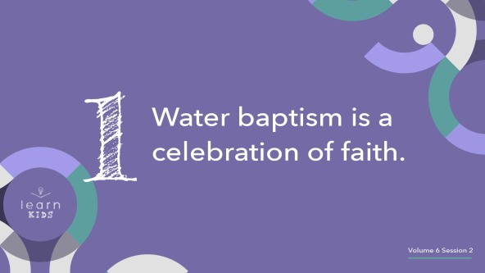

It’s easy to get confused about why we do water baptism and what it really means. Why do you think people get confused? *(Allow responses.)* One reason is because different churches do it differently for different reasons.

To clear things up, we believe that water baptism is a symbol of the faith or belief someone has in God. What’s a *symbol*? *(Allow responses.)* A symbol is something that represents or stands for something else. For example, the Cross is a symbol of Jesus’ death and resurrection.

We believe that you should be baptized in water after you have asked Jesus to forgive you for the wrong things you’ve done and believe that He is your Savior. When you take this step of water baptism, you’re making a public statement that you’ve decided to follow Jesus. It also lets you share this good news with other Christians who will want to celebrate with you.

The act of being baptized in water isn’t the same as salvation, which is asking Jesus to forgive your sins. Instead, water baptism lets others know that you’ve decided to follow Jesus. It gives others the opportunity to celebrate your choice to live for God. Look at it this way.

• *Pull out a party horn and blow on it*.

Who loves birthday parties? *(Group response)* Birthday parties are the best, especially when it’s your birthday. A party doesn’t make that day your birthday. It’s simply a celebration of the fact that you had a birthday. It doesn’t even have to be on your actual birthday because it’s only a celebration of the fact that you were born. Water baptism is a celebration of the fact that you have believed in Jesus and asked Him to forgive your sins, the wrong things you’ve done.

**2. Water baptism is an act of obedience to God**.

• *Show the* ***Teaching Point 2 Slide***.

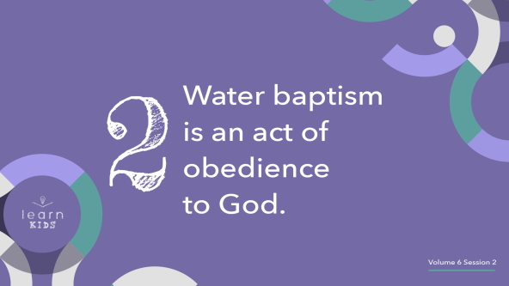

Is it important for you to obey the instructions and rules your parents give you*? (Group response)* Why is that*? (Allow responses.*) Is it more important for us to obey what God has told us to do in His Word? *(Group response)*

• *Hold up the Bible*.

Besides having the opportunity to celebrate such an important life decision with our church family, there are more reasons to be baptized in water. We should be baptized in water because the Bible tells us that Jesus said to do it.

When Jesus told His disciples to go and tell the world about Him, He also told them to baptize His new followers. That’s why every person who chooses to follow Jesus should also obey His instruction to be baptized in water. Being baptized in water is so important to Jesus that He set the example and was baptized in water when He was an adult.

Think about it. Why would Jesus need to be baptized? He never sinned and didn’t need to ask God for forgiveness. John the Baptist, who baptized Jesus, was confused about this as well. John even said that Jesus should be baptizing him. Jesus explained that He was being baptized in water because it was the right thing to do. He set an example for all of us to follow.

**3. Water baptism is partnering with Jesus**.

• *Show the* ***Teaching Point 3 Slide***.

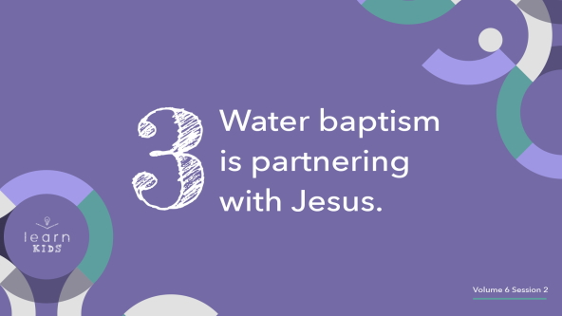

You may have heard that water baptism helps us identify with Jesus’ death and resurrection. Water baptism is a symbol of how Jesus was buried when He died and then rose from the dead. Just like Jesus was buried completely in a tomb, we do water baptism by complete immersion in water. Think of this bath toy as a new Christian.

• *Hold up the bath toy and place it in the shallow container filled with water*.

• *Push the bath toy under the water briefly while you talk*.

When we go down under the water, it’s a symbol of Jesus going down into the grave when He died. We’re showing others that we want to partner with Jesus by dying to our sins and leaving the past behind us. Then, we come up out of the water.

• *Bring the bath toy up out of the water*.

It’s also a symbol of how Jesus rose from the dead three days later. We show others that we want to partner with Jesus in this, too. We want to rise above our past and the wrong things we’ve done to a new life with Jesus. Remember, water baptism is one of the big steps in our faith walk that’s meant to be done publicly. When you’ve received salvation by asking Jesus to forgive your sins, the next step is to show your faith to your church family. We’re here to help each other grow, love each other, and celebrate together.

**Prayer and Response**

*Consider playing a worship song softly in the background while kids pray*.

I want to take the time for us to celebrate with anyone who is interested in being baptized in water. If you’ve asked Jesus to forgive your sins and haven’t taken that next step to be baptized in water, you can make the decision today. Raise your hand if you’re interested in getting baptized in water. *(Allow responses.)* Let’s take a moment to celebrate those who are interested in being baptized in water.

• *Lead the group in cheering and celebrating*.

**Prayer**

• *Optional: Have the kids repeat phrases of the prayer after you*.

|  |
| --- |
| Dear God, thank You for showing us the importance of being baptized in water as a symbol of our faith in You. We want to celebrate what You’re doing in our life today. Amen. |

**Faith Verse**

I’m so thankful that God is here with us right now. How do I know? Our Faith Verse tells us that. Let’s say our Faith Verse and do the actions together.

• *Play* ***Faith Verse Video***.

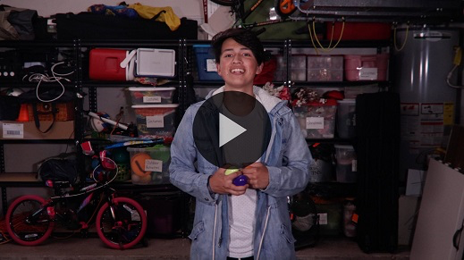

[Matthew 18:20](https://ref.ly/logosref/Bible.Mt18.20) (NLT)

“For where two or three gather together as my followers, I am there among them.”

When we gather as a church family, God is going to be there also.

**Faith Fact**

Before we go to our small groups, let’s review our Faith Fact again.

• *Show the* ***Faith Fact Slide***.



Say it with me. **We celebrate together**. Let’s celebrate together one more time before we go to our small groups.

• *Lead the kids in celebrating for a few seconds*.

• *Dismiss kids to Small Group time or to go home if your group time ends here*.

**Small Group**

**30 Minutes**

*This section can be done in conjunction with the large group or on its own if you do small groups with your kids. During Small Group time, the goal is to connect the kids with the Word of God and to each other. All activities are led by the small group leader.*

**Group Connection**

**Over, Under**

|  |
| --- |
| ***You Will Need***   * *Large sponges, two per group* * *Buckets, four per group* * *Water*   ***Getting Ready***   * *Choose a place to play that can get wet.* * *Fill two of the buckets for each small group each about 3/4 full of water.* |

Since we’ve been talking about water baptism, I thought we should play a water game. This game requires everyone to work together, and you might get a little wet.

Let’s move into two teams. Each team will get a bucket filled with water, a sponge, and an empty bucket. The goal is to get as much water from your filled bucket to your empty bucket using only the sponge. There’s another catch. You’ll have to send the sponge from teammate to teammate by going over your head and then under your legs. You’ll follow this pattern: over, under, over, under, etc. The last person in line will wring out the sponge into the bucket, run it back to the front of the line, dip it in the water, and pass it again. The team with the most water in their bucket when time is up wins.

• *Have teams line up with some space between each kid. Place the full bucket and sponge at the front of each line and the empty bucket at the end of each line*.

• *Remind the kids to use the over-under-over-under pattern to pass their sponges down the lines to the empty buckets*.

• *Allow them to play for a few minutes. Then, say, “Stop.” The team with the most water in their originally empty bucket wins*.

Let’s celebrate and cheer for the winning team.

• *Lead the kids in celebrating*.

That was a lot of fun whether your team was the winning team or not. Great job celebrating together!

**Learn about It**

|  |
| --- |
| ***You Will Need***   * *Bibles for kids in your group to share*   *No prep needed for this activity.* |

**Scripture Search:** [**Matthew 3:13–17**](https://ref.ly/logosref/Bible.Mt3.13-17)**;** [**Matthew 28:19**](https://ref.ly/logosref/Bible.Mt28.19)**;** [**Acts 10:47–48**](https://ref.ly/logosref/Bible.Ac10.47-48)**;** [**Galatians 3:26–27**](https://ref.ly/logosref/Bible.Ga3.26-27)**,** [**1 Thessalonians 5:16–18**](https://ref.ly/logosref/Bible.1Th5.16-18)

Let’s see what else God’s Word has to say about the importance of water baptism. As we find and read each of these verses, let’s consider: What does this Scripture mean for our life today?

• *Give each kid a Bible and search for one or more of the Scriptures as a group together (as time allows). When everyone has found the Scripture, have one of the kids read it. Then, answer the questions about it*.

• *Pair kids who need additional help with older kids or start simple and look up the session’s Bible story Scripture:* [*Acts 16:11–15*](https://ref.ly/logosref/Bible.Ac16.11-15)*. Kids will get better finding Scriptures the more they practice*.

• *Optional: Make this a competition to see who can find the Scripture first*.

**Bible Reading Tip**

Many topics in the Bible, such as water baptism, can be found in different books and chapters throughout the Bible. It’s fun to look at what the whole Bible says about a topic and read the different Bible stories about it. Some Bibles have a topical index in the back to help you find different verses that reference the same topic. An easier option we have today is to look things up on the Internet. With your parent’s permission or help, do a quick Internet search for “Bible verses about water baptism.” You’ll easily find many verses to read on that topic.

**Challenge**

Bible reading can become just another thing to check off our to-do list each day. We don’t want that to happen. Reading the Bible should be fun and interesting. When you come across a verse or story that you love, celebrate it by highlighting it (with your parents’ permission to write in your Bible). You can even write a little note in your Bible that says what you love about it. When you read that verse or section of the Bible in the future, it will remind you of what you learned from that Scripture in the past. Find at least one verse or story to celebrate this week while you read your Bible.

**Faith Fact**

There are some hard or difficult things we have to do as followers of Jesus. I’m thankful for some of the fun things we get to do like celebrating all that God has given us and done for us. Let’s say our Faith Fact together. **We celebrate together**.

**Group Discussion**

*Feel free to use all or just a few questions as a jumping-off place for good discussion. Questions marked with * are designed for more conversation. Adjust the questions based on the age or maturity of your group. Typically, older kids will be able to dive a little deeper than younger ones*.

**Questions**

• *If small group activities are not immediately following large group time, you may want to read the Bible story passage before this discussion*.

Who was Lydia? (See [Acts 16:14](https://ref.ly/logosref/Bible.Ac16.14).)

What did Lydia decide to do after she listened to Paul’s teaching?

Does water baptism save you?

What is water baptism a symbol of?

Have you celebrated with others when they were baptized in water?

* Have you been baptized in water? What was being baptized like for you?

* If you answered no, have you thought about being baptized in water? Why or why not?

What do you think about Jesus’ example of being baptized?

* Do you have any questions about water baptism?

**Prayer Requests**

*Finish group discussion by sharing prayer requests and praise reports. Keep track of your small group’s prayer requests and review them each time you meet*.

**Prayer**

*Have kids pray for each other’s prayer requests*.

**Faith Verse Review**

Our Faith Verse reminds us of the importance of coming together as a church family. It’s even better if we have a special reason to celebrate when we come together.

• *Show* ***Faith Verse Video***.



[Matthew 18:20](https://ref.ly/logosref/Bible.Mt18.20) (NLT)

“For where two or three gather together as my followers, I am there among them.”

Say the Faith Verse with me and do your best to remember it. You’ll need to know it to play our Faith Verse game.

• *Say the verse as a group a couple of times*.

**Faith Verse Fun**

**Cheer about It!**

Today, we learned about celebrating together. We’re going to celebrate with our Faith Verse. Let’s form into two teams. Each team will come up with a way to turn the Faith Verse into a cheer. The team who creates the better cheer to celebrate the Faith Verse will be the winner. Are you ready to celebrate? *(Group response)*

• *Allow the teams a few minutes to come up with a cheer*.

• *Give each team time to present their Faith Verse cheer. Then, choose who celebrated better*.

You did an amazing job celebrating the Faith Verse together. Thanks for giving it your all and cheering together with your team.

**Activity Page**

**Water Baptism**

|  |
| --- |
| ***You Will Need***   * ***Small Group Activity Page****, one per kid* * *Crayons or markers*   ***Getting Ready***   * *Print copies of the* ***Small Group Activity Page****, one per kid.* |

On your Activity Page today, you’ll see pictures of what happens when someone is baptized in water.

• *Give each kid a copy of the* ***Small Group Activity Page*** *and markers or crayons*.

There are some words missing in the steps. Can you figure out what each one should say?

• *Help younger kids fill in the missing words as needed*.

In the last picture, there isn’t a word missing; instead, there’s a person missing. I hope that everyone who believes in Jesus chooses to get baptized in water. Draw yourself being baptized in that picture.

• *Optional: Talk about your own water baptism experience as kids draw*.

• *Let kids color the rest of the pictures*.

**Dismissal**

It has been so much fun celebrating with you today! I can’t wait for the next water baptism service to see who decides to publicly tell everyone that you are a follower of Jesus. Make sure you talk to your parents if you would like to be baptized in water. Let’s pray.

**Prayer**

|  |
| --- |
| *Dear Jesus, thank You for an amazing church family to celebrate with. Help us to all follow Your example and choose to be baptized in water. Amen.* |

**Faith Fact Recap**

• *Show the* ***Faith Fact Slide***.



Before you leave, let’s say our Faith Fact together one more time but make it a really big celebration. I want your parents to hear us. **We celebrate together.** I can’t wait to come together as a church family and do this again next time.

• *Send home the* ***Small Group Activity Page***.

• *If possible, talk to parents of the kids who would like to be baptized in water*.

• *Remind parents that there are* ***Family Devotions*** *available on the app to do with their kid*.

• *Tell everyone the date and time for the next session*.